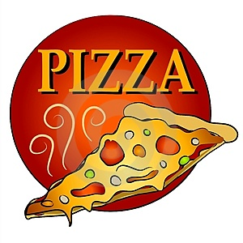

Congratulations, ____________________
You received no late assignments this month!
You will get pizza on Wednesday, February 3rd for lunch.
You must bring $3.00 for your pizza by February 1st. Thanks!
You may bring your own drink, or bring $1.25 for the vending machines.

Congratulations, ____________________
You received no late assignments this month!
You will get pizza on Wednesday, February 3rd for lunch.
You must bring $3.00 for your pizza by February 1st. Thanks!
You may bring your own drink, or bring $1.25 for the vending machines.

