
Pawnee Schools Management Plan
Expectations
1. Follow rules the first time given.
2. Keep hands, feet, and objects to yourself.
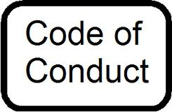
3. Use positive language. Harassment, put downs, teasing, bullying, and foul language will NOT be tolerated.
4. Stay in your assigned area.
5. Be on time and prepared.

